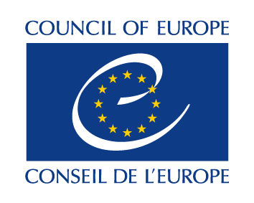
Launching event of the CoE Action Plan for Azerbaijan 2022-2025
Baku, 5 April 2022
Hotel Hilton – Sevda Ballroom
Draft Agenda
09:30 Registration of participants

10:00 Opening session
Speeches by
Ms Marija Pejčinović Burić, Secretary General of the Council of Europe
Mr. Fikrat Mammadov, Minister of Justice of the Republic of Azerbaijan

10:20 Information session held by CoE Office, Ministry of Foreign Affairs and Presidential Administration
Presentation of the CoE AP for Azerbaijan 2022-2025 by Ambassador Zoltan Hernyes,
Head of the Council of Europe Baku Office
Remarks by Mr Habib Mikayilli, Head of Division on International Organizations at Foreign Policy Issues Department, Presidential Administration
Remarks by Ms Aysel Yagubova, Head of Department for the Cooperation with International Human Rights Institutions of the Azerbaijani Ministry of Foreign Affairs

11:00 Discussion with national stakeholders

11:30 End of the event, closing remarks, followed by a light reception

Notice:
The opening and information sessions are open to the media upon prior accreditation.
The Secretary General will need to leave the event before the discussion with national stakeholders.
English/Azerbaijani simultaneous interpretation will be provided
COVID-19 regime to be strictly observed

